Template – 2 days Certificate in Dental Assisting
Introduction
Hi !

Thank you for your interest in our Basic Certificate in Dental Assisting course.

Below are the available dates for the upcoming intake dates:
• 15th to 16th July 2026 (Weekdays)
• 25th & 26th July 2026 (Weekends)
• 12th to 13th August 2026

The course fee is $600 nett for a duration of 2 consective days, from 930am to 530pm at our HQ, Clementi Loop. For more details on the contents, please visit our website at https://qandm.edu.sg/Courses/Dental-Assistant/4/Basic-Certificate-In-Dental-Assisting. Payment wise, you may use Skillsfuture Credit to pay for course fee.

If you are interested in enrolling, let me know and I'll be happy to assist 😊

Mode of Payment

There are three modes of payment.

1) Skillsfuture Credit Base tier
(Please note that our course is not eligible for Midcareer Skillsfuture credits)

2) Paynow. UEN: 201841969G

3) NTUC Union Membership: 50% off course fee. You'll have to pay upfront first and get reimbursed after completion of course. You are not able to use both Skillsfuture credit and Union member fee. Can only use either uTap or Skillsfuture Credits

If you are interested in enrolling, let me know and I'll be happy to assist 😊

ENROLLMENT
If you are interested in enrolling, please provide the following details for registration, and I will promptly email you the confirmation along with your information:

1. Full Name (as per NRIC):
2. NRIC Number:
3. Date of Birth:
4. Email Address:
5. Mobile Number:
6. Kindly indicate whether you will be using SkillsFuture credits or PayNow/internet transfer to pay for the course fee.

Please note that there are two tiers of SkillsFuture Credit. Our courses are only eligible for the basic tier, and the Mid-Career SkillsFuture Credit cannot be used for this course.

You can check your SkillsFuture credit balance using the link below and let me know how much credit you’ll be using to pay for the course:

https://sfc.myskillsfuture.gov.sg/claim

This information will help me generate an accurate invoice for your SkillsFuture claim submission. Once I receive your details, I will generate the invoice and email you the steps to claim from the SkillsFuture portal.

Looking forward to your reply!

Can use Midcareer Skillsfuture?
There is two tiers of SkillsFuture Credit. Our courses are only eligible for the basic tier. *You cannot use Midcareer Skillsfuture Credit to pay for this course fee.*

You may login Skillsfuture Portal to find out the balance of your "basic tier" skillsfuture credits.
https://sfc.myskillsfuture.gov.sg/claim
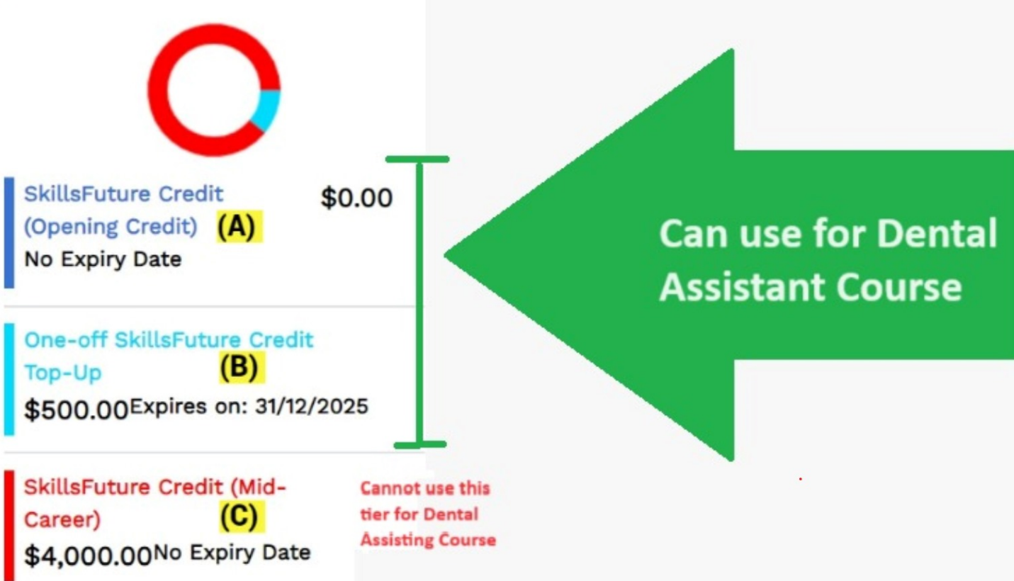

Why is your course so expensive?
Thank you for your feedback regarding the course fee. We understand that cost is an important consideration, and we strive to ensure that our pricing reflects the value and quality of the education and resources provided.

The fee for our 2-day course includes comprehensive materials, expert instruction, and access to specialized equipment and facilities. We believe this investment will greatly benefit your professional development and skillset.

However, we do appreciate your concerns and will take them into consideration for future planning. If there are specific aspects of the course or pricing you'd like to discuss further, please feel free to reach out :)

Will I be offered a position at the end of the course?
We do offer job opportunities for suitable candidates on the last day of the class.

Selection process from the HR involves various contributing factors to ensure we find the best fit for the role. Factors includes
- Location of work place
- Schedule
- Skills and Experience
- Cultural Fit
- Interview Performance

What is the minimum qualification to attend 2 days DA course?
We prefer candidates with GCE 'N' Levels. However, if you do not have GCE 'N' Levels, we are open to considering candidates who have basic reading and writing skills in English, as the assessment will be conducted in English. :)

How to Apply for UTAP Funding Support:
All NTUC Union members are eligible for 50% unfunded course fee support, up to $250 per year (or up to $500 per year for NTUC members aged 40 and above) through the Union Training Assistance Programme (UTAP) for this course.
How to Apply for UTAP Funding Support:
Step 1: Ensure your NTUC Union membership is valid. You can check your membership status by:
- Chatting with NTUC’s Chat Bot at ntuc.co/chat
- Logging into your U Portal at www.ntuc.org.sg
Step 2: Enroll in the course and attend both days of training.
Step 3: After completing the course, log in to your U Portal account here to submit your UTAP claim.
You will need the following documents to complete your claim:
- Proof of Payment (e.g., Course Invoice/Receipt)
- Proof of Completion (e.g., Certificate/Results Slip)
Both documents will be provided to you after the course.
Important: Please submit your UTAP claim within 6 months of course completion. Late submissions will not be accepted.

